(Note: Some of the multiple-choice answers may have gotten mixed up) +++++++++++++++

**Key - Form 1**

1. 0.47 ~ B: Sales increased between 2003 and 2008
2. $53500-2600x$ ~ $\$35300$
3. 17 ~ 23.25
4. $1.95x+250$ ~ $3.17x$ ~ $1.22x-250$ ~ 205
5. 504 ~ 63
6. 0.25
7. C: 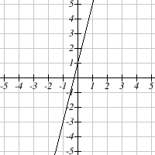
$-\frac{11}{10}x-1$

8. $\frac{3}{5}$ ~ -1
9. B: The cost of silk screening a design on T-shirts is $16 for each shirt created and  
   a $28 design fee.
10. A: 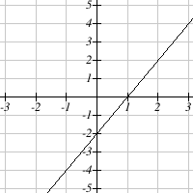
11. A: $f\left(-4\right)=158$
12. C: (3,10)
13. 20000 ~ 15 ~ 232
14. 2956

License info at: <https://www.myopenmath.com/course/showlicense.php?id=98383-1332524-98381-19217-113465-54828-15593-1332529-1440-73942-3461-98401-1332535-1116592-1332516-1330172-1331952>